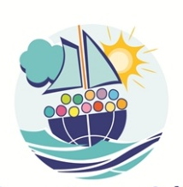
Coordinator’s council - Egypt 2026
Registration form
To complete and send BEFORE 16 February 2026
1 form
per person
to international@foietlumiere.org

Please enclose a copy of your passport,
which should be valid at least until May 2027.

Faith and Light Province:
NAME:
First Name:
Birth date:
Email:
Phone:
Address:
Country:
Specify your departure airport:
Responsibility in Faith and Light:
Christian denomination:
Within Faith and Light, I am:
parent of a person with a disability person with a disability friend
chaplain
Language(s) spoken:
The translation will be available in the following languages. Please tick the one you need:
English French Spanish Polish Portuguese /Brazilian
Italian Arabic
Diet / allergies:

Mobility: do I need a wheelchair? Yes / No
I can join the music team Yes / No
Comments:

